# Assignment 2

Employee (empno, emp_name, salary, hiredate, city) [empno should starts with ‘E’]

Department (deptno, dname, city)

Manager (mgrno, deptno, manger_name, salary, hiredate,city) [mgrno should starts with ‘M’]

Empmgr (empno, mgrno)

Create table through appropriate SQL commands. Define all integrity constraints and enter sufficient data.

Write SQL commands for the following queries.

i) Give the employee names who earn more than their manager.

ii) Give the name of the managers who have no employee under his supervision from the same city as of him.

iii) Give the name of the manager who has maximum number of employees under his supervision.

iv) Give the name of the employees who have been hired in the year 2006.

v) Give the name of the city where no manager is located.

# Solution

## Table creation:

### Employee

create table employee(empno varchar2(3) primary key, emp_name varchar2(10), salary decimal(8,2), hiredate date, city varchar2(20), check(empno like 'E%'));

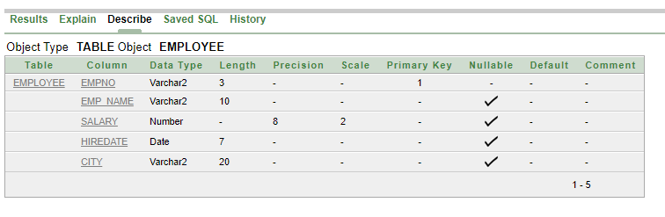

### Department

create table department(deptno varchar2(3) primary key, dname varchar2(20), city varchar2(20));

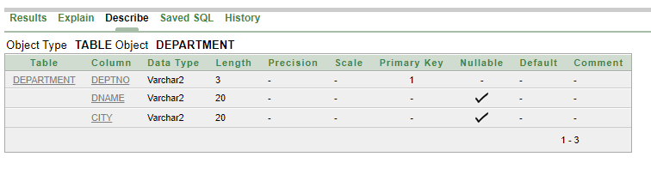

### Manager

create table manager(mgrno varchar2(3) primary key, deptno varchar2(3) unique, manger_name varchar2(10), salary decimal(8,2), hiredate date, city varchar2(20), check(mgrno like 'M%'), foreign key(deptno) references department(deptno));

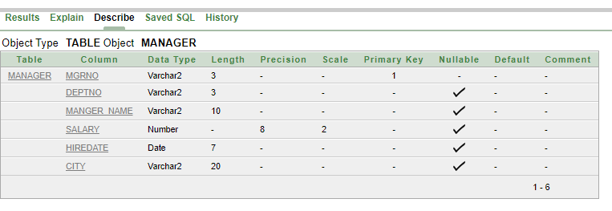

### Empmgr

create table empmgr(empno varchar2(3), mgrno varchar2(3), primary key(empno, mgrno), foreign key(empno) references employee(empno), foreign key(mgrno) references manager(mgrno));

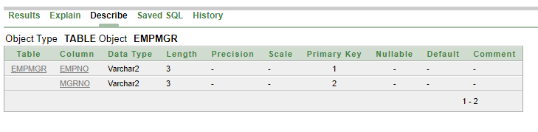

## Value insertion

### Employee

insert into employee values('E01', 'Mukesh', 50000, date'2009-03-24', 'Howrah');

insert into employee values('E02', 'Prakash', 32000, date'2010-04-03', 'Kolkata');

insert into employee values('E03', 'Bikash', 25000, date'2012-06-10', 'Burdwan');

insert into employee values('E04', 'Koushik', 38000, date'2006-06-10', 'Kolkata');

insert into employee values('E05', 'Sayan', 45500, date'2006-07-25', 'Singur');

insert into employee values('E06', 'Ratan', 48900, date'2007-03-29', 'Siliguri');

insert into employee values('E07', 'Rajesh', 27700, date'2007-11-25', 'Ranchi');

insert into employee values('E08', 'Sanjay', 29600, date'2009-10-16', 'New Jalpaiguri');

insert into employee values('E09', 'Kamalesh', 54820, date'2010-08-12', 'Kolkata');

insert into employee values('E10', 'Pritam', 24780, date'2008-04-07', 'Howrah');

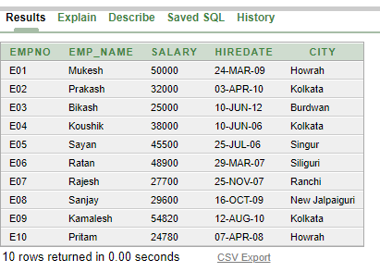

### Department

insert into department values('D01', 'Finance', 'Mumbai');

insert into department values('D02', 'Management', 'Pune');

insert into department values('D03', 'Engeneering', 'Kolkata');

insert into department values('D04', 'Research', 'Siliguri');

insert into department values('D05', 'Health and medical', 'Howrah');

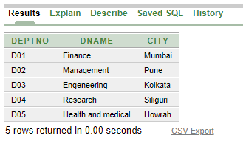

### Manager

insert into manager values('M01', 'D01', 'Ramesh', 46700, date'2012-04-23', 'Burdwan');

insert into manager values('M02', 'D02', 'Kailash', 74750, date'2007-01-15', 'Howrah');

insert into manager values('M03', 'D03', 'Sudhir', 54820, date'2009-03-24', 'Siliguri');

insert into manager values('M04', 'D04', 'Ashish', 44570, date'2010-09-03', 'Darjeeling');

insert into manager values('M05', 'D05', 'Amish', 34590, date'2007-07-19', 'Kolkata');

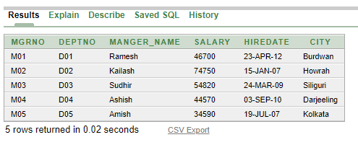

### Empmgr

insert into empmgr values('E01', 'M01');

insert into empmgr values('E02', 'M01');

insert into empmgr values('E03', 'M01');

insert into empmgr values('E04', 'M04');

insert into empmgr values('E05', 'M04');

insert into empmgr values('E06', 'M04');

insert into empmgr values('E07', 'M02');

insert into empmgr values('E08', 'M02');

insert into empmgr values('E09', 'M03');

insert into empmgr values('E05', 'M03');

insert into empmgr values('E10', 'M05');

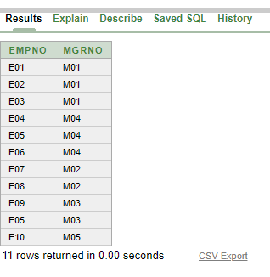

## Queries

1. Give the employee names who earn more than their manager.

ans. select empno, emp_name from employee where empno in (select distinct employee.empno from employee, empmgr, manager where employee.empno = empmgr.empno and manager.mgrno = empmgr.mgrno and employee.salary > manager.salary);

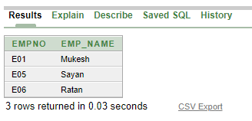

1. Give the name of the managers who have no employee under his supervision from the same city as of him.

ans. select mgrno, manger_name from manager where mgrno not in (select distinct manager.mgrno from employee, empmgr, manager where employee.empno = empmgr.empno and manager.mgrno = empmgr.mgrno and manager.city = employee.city);

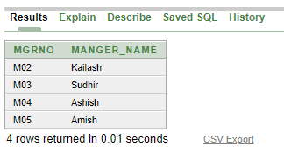

1. Give the name of the manager who has maximum number of employees under his supervision.

ans. select mgrno, manger_name from empmgr natural join manager group by mgrno, manger_name having count(empno) = (select max(count(empno)) from empmgr group by mgrno);

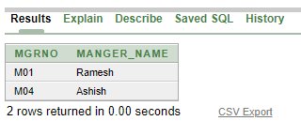

1. Give the name of the employees who have been hired in the year 2006.

ans. select empno, emp_name from employee where extract(year from hiredate) = 2006;

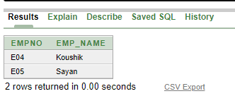

1. Give the name of the city where no manager is located.

ans. select mgrno, manger_name from manager where city not in ((select city from employee) union (select city from department));

